Create Node-RED Service

|  |  |
| --- | --- |
| **Date** | **29 October 2022** |
| **Team ID** | **PNT2022TMID18904** |
| **Project Name** | **Project – Industry specific intelligent fire management system.** |
| **Maximum Marks** | **4 Marks** |
|  |  |

Aim: To create a web application create a Node-RED service. Steps followed:

* Navigated to the App creation page

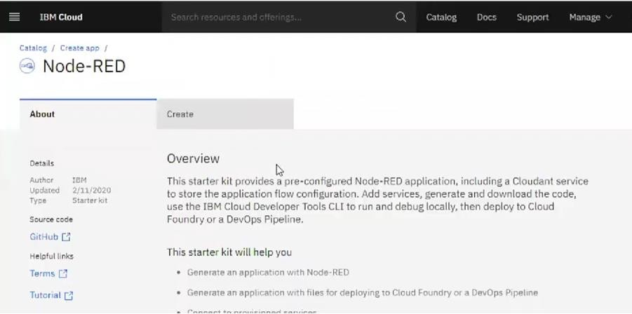

* + Entered project details and clicked on create

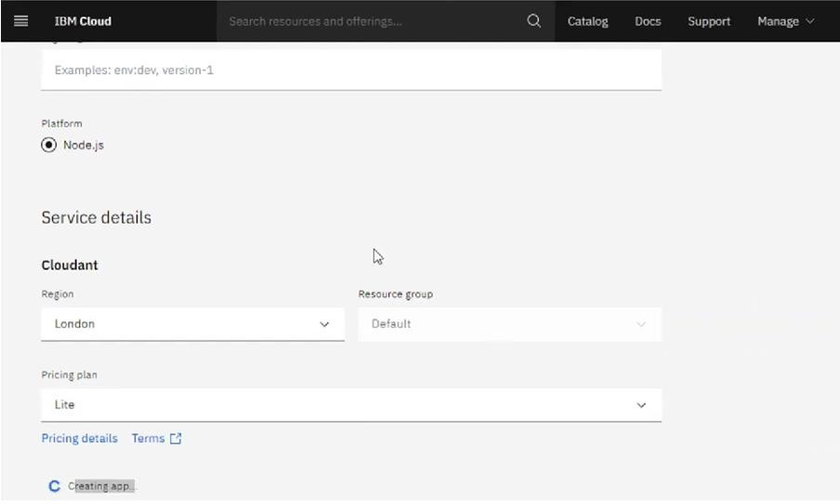

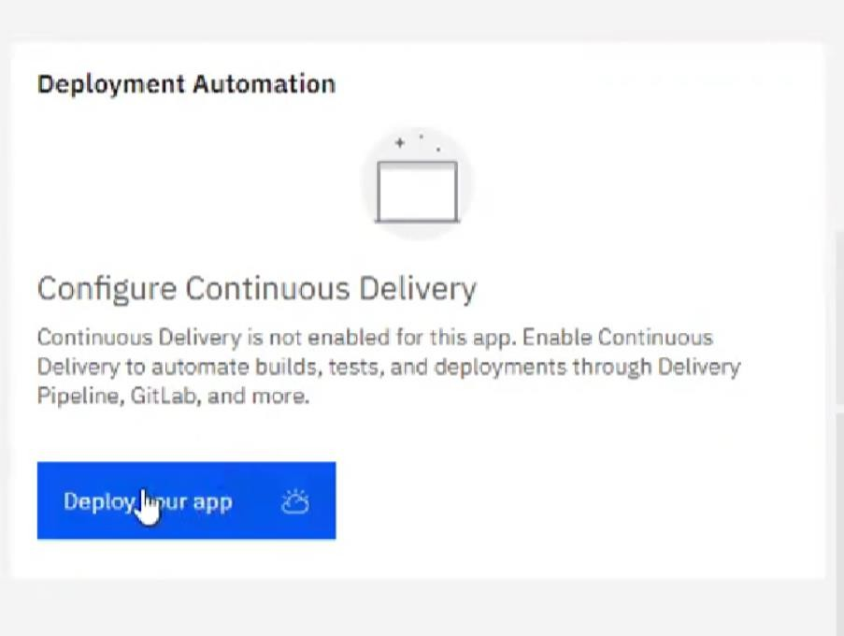

* Setting up the environment and deploying the app

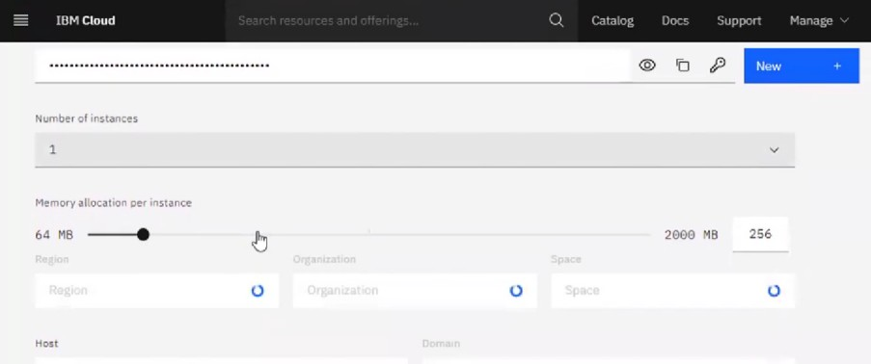

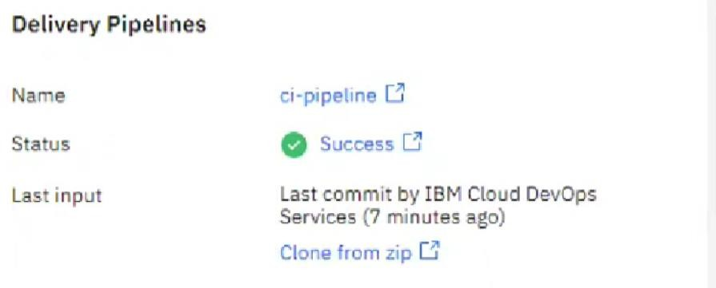

* Dragged and dropped components into the editor

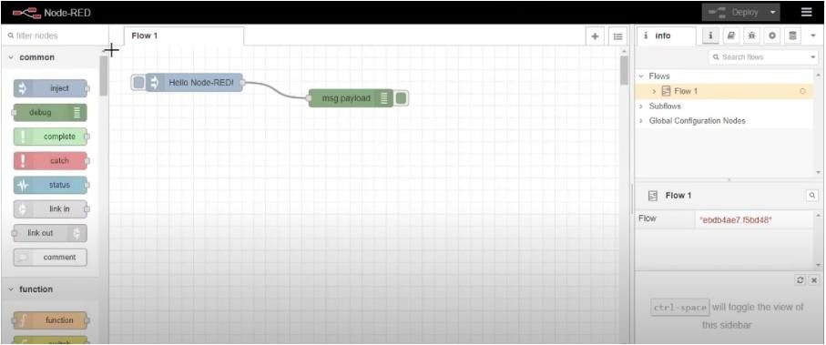

* Editing some values of the properties

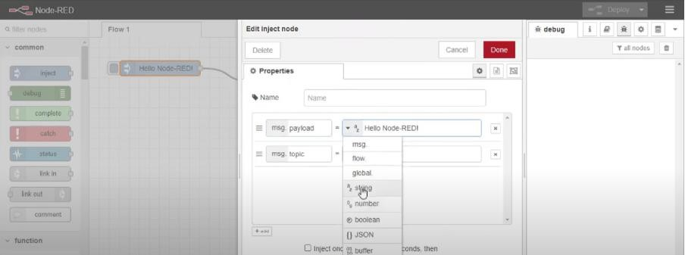

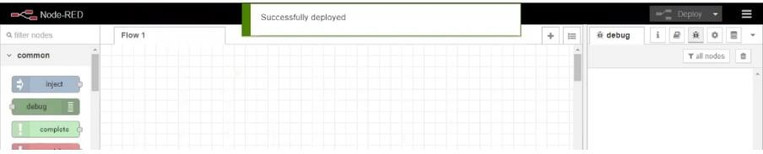

**Result: Successfully created a NodeRED service on IBM Cloud**